

USING “KINOVEA” FOR HORIZONTAL JUMPS TAKE-OFF REVIEW

This is a classic case where “doing it” is ten times easier than either writing or understanding instructions. Don’t be deterred. If I can do it, anyone can!
Malcolm Rogers

REMEMBER: The Board Judge is the decision maker. They may, if they wish occasionally ask you to look at a close decision for them. Equally, if you spot an obvious error of judgement you might want to quietly suggest that they have a look at the screen. Our experience is that 99% of the time, they get it right first time!
An athlete making an immediate protest may also ask for a review. The Referee should be involved.
(Sorry about the wavy lane lines on the screenshots … lens distortion!)
SETTINGS
Having launched Kinovea from the Windows menu, other than indicated below, you should not need to alter any settings. USUALLY EVERYTHING WILL HAVE BEEN DONE FOR YOU, SO YOU CAN SKIP STRAIGHT TO “RECORDING”.
CHOOSING AND ADJUSTING THE CAMERA (See below)
- Icons for any connected cameras should appear on the initial screen when you launch Kinovea. This will include any inbuilt webcam on the laptop.
- The camera you require will normally appear as “USB Video Device”. (See below for Triple Jump.)
- Clicking on this in the “Cameras” list on the left, should bring up the camera view. (Or use the icons mentioned above.)
- At this stage, you will need the laptop next to the camera at the board so that you can move the camera base whilst aligning the camera and observing the screen. (Or an obedient assistant with good motor skills!) Usually, this will have been done for you in advance.
- Click on “Tools” in the dropdown menu at the top left. Then click on “Camera Test Grid”.
- This will overlay the image on the screen with a grid of red squares.
- Align the edge of the take-off board nearest the pit parallel to one of the vertical lines by moving the camera base. (Because the camera is currently there only to assist the take-off judge, the precise alignment required by Seiko or Omega is not required, but get as close to parallel as you can. See picture below.)
- Use the menu as above to remove the grid lines.
3. “Tools” then “Camera test grid” will overlay the red grid lines.

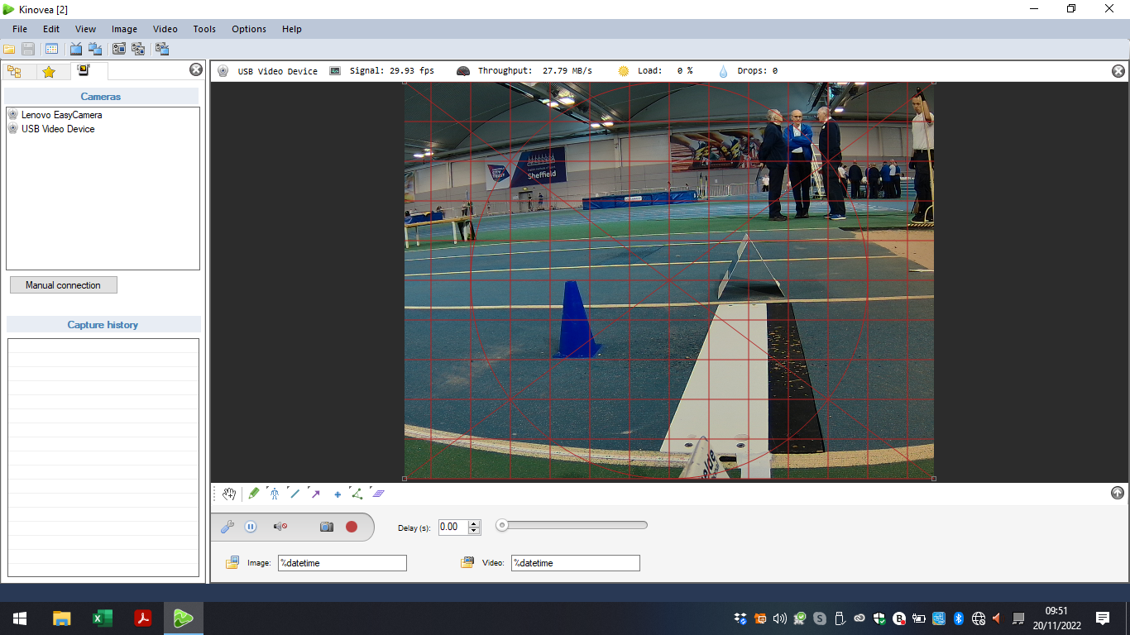
1. Camera icons also appear on the initial screen, but this menu is the easiest way to select. “USB Video Device”
4. You’re only aiming to get this edge as parallel as possible to the grid lines, not trying to line up a cursor. Normally this will have been done for you.
2. At this stage “One capture screen “will give you a single picture.

TRIPLE JUMP
Sometimes, there will be two USB Video Devices. They will be labelled “One” and “Two”. “One” is always the camera nearest to pit. (Allowing the use of more than one board at domestic level complicates matters! At national/international level, only one board is allowed!) For Triple Jump you can switch between the two.

CHOOSING SCREENS (See below)
- Use either the dropdown “View” menu, or the camera icons below it to view “One capture and one playback screen”. The two sceens will appear side by side.
I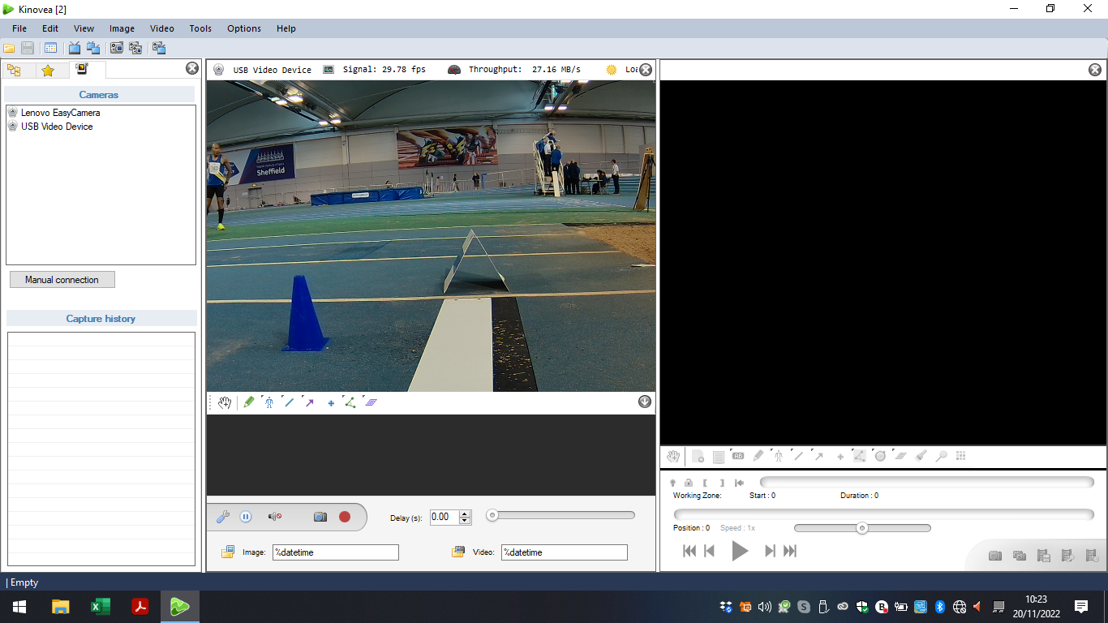
A blank screen because you haven’t recorded anything yet!
Click “One capture and one playback screen”. The playback screen appears on the right.

RECORDING (See below.)
- Make sure the cursor is inside the recording screen. (It’s not easy to see, so position it in the camera area and then drag it across.)
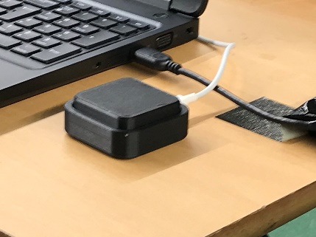
- Press the black keypad to start the recording, when the athlete is around 15 metres from the board. “Recording started” will appear on the screen. The programme is pre-set to record for 4 seconds, after which it will automatically stop. (See next page “Capturing the recording.”)
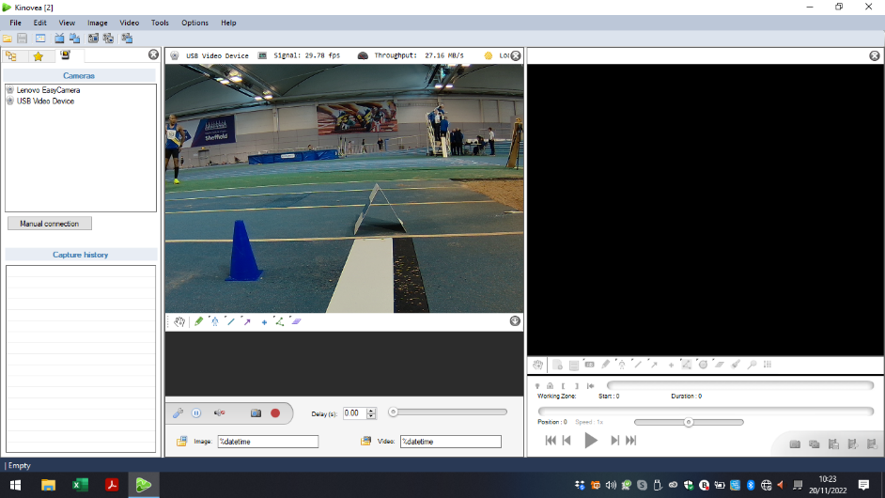

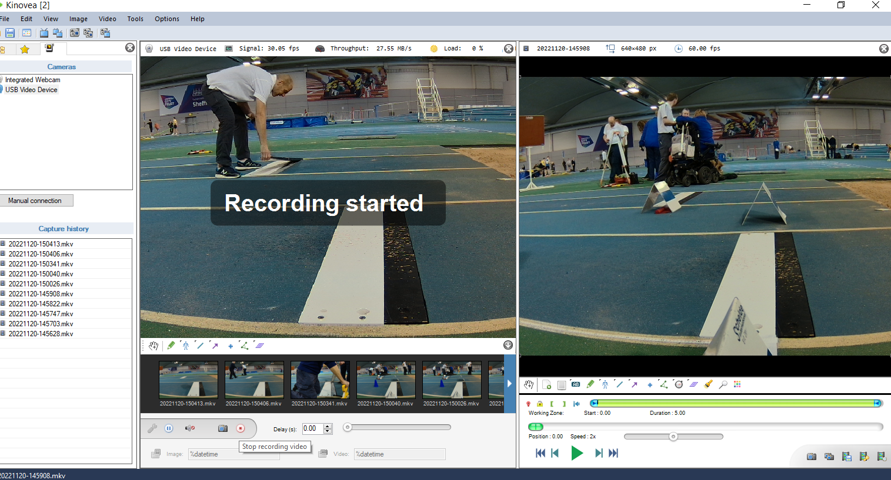

CAPTURING THE RECORDING (See below.)
90% of the time you won’t need to transfer the recording! A “valid jump”, or a “no jump” will be clear as you watch the recording screen.
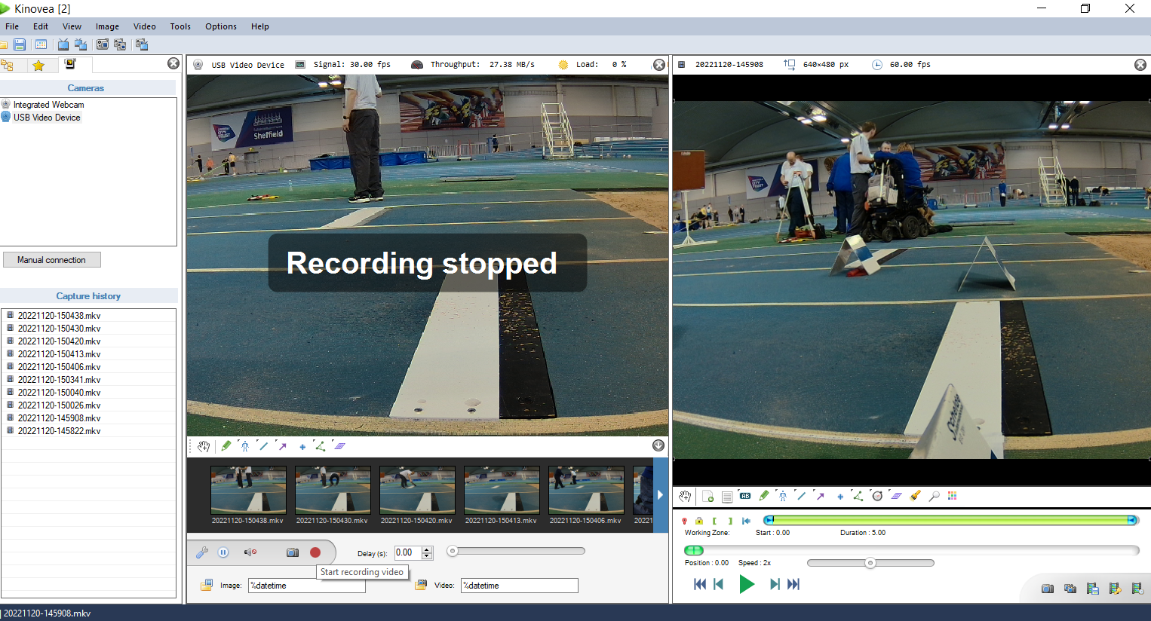
1. When the recording stops a label will appear on the capture screen to confirm, and shortly afterwards this list will “blink” as it updates. Double click on the top item and the last recording should appear in the playback screen. It will take a second or two to load.
2. Click and drag this slider to the right to scroll through the recording. You can stop and rewind as required. (See below.)

- It’s easiest to click on the top item on the “Capture History” menu, on the left of the screen.
- You can click on the smaller images below the capture screen but identifying the last one can be confusing.

VIEWING THE RECORDING (See above.)
- Click on the oval green buttonand drag to the right. Pause and rewind as necessary.

HOWEVER, SEE BELOW FOR A BETTER PROCEDURE.

FIRST Dragging this button to the left, to around 40% sets a suitable scroll speed.
SECOND Starting playback will leave the last recording scrolling through until you transfer the next one. This allows athletes to look over your shoulder and see their take-off should they wish to.

BUT ONLY REPLAY BEYOND THIS, IF THE ATHLETE MAKES A FORMAL PROTEST! CALL THE REFEREE.

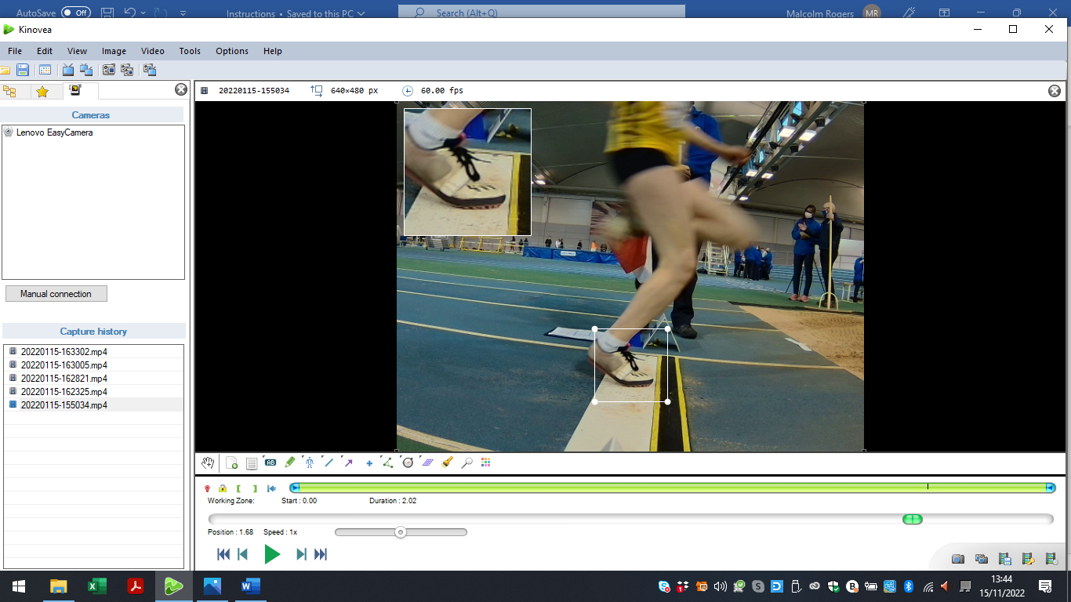
MAGNIFYING PART OF THE IMAGE (See below.)
Clicking on this icon will bring up the white outlines, as shown. Drag to the area you require, and the magnified image is in the top left- hand corner of the screen.
The slider has simply been dragged to the required point of the recording.

- This can be a useful tool with close decisions.
- (For clarity, only the playback screen is shown. In reality, the two screens will still be side by side.)

SAVING THE RECORDING
- Recordings save automatically. Whilst only the last ten appear in the “Capture History” menu, they have all been saved eleswhere in a Kinovea folder.

THE NEXT TRIAL
- …. which means all you have to do is reposition the cursor in the capture screen and press the black keypad again for the next trial.

Malcolm Rogers November 2024

